Professional Readiness for

Innovation,Employability Inno

AndAEntrepreneurshipurship

SMART HOME

Submitted By:

**R.N.NIGISHA**

**961819106039**

**B12-6A2E**

**Door Buzzer Using Ultrasonic Sensor**

CODE:

// Door Alarm Using Arduino UNO and Ultrasonic Sensor

// Code to be used in the Text sub-window of tinkercad.com circuit page

int trigger_pin=2;

int echo_pin=3;

int buzzer_pin=10;

int time;

int distance;

void setup()

{

Serial.begin(9600);

pinMode(trigger_pin,OUTPUT);

pinMode(echo_pin,INPUT);

pinMode(buzzer_pin,OUTPUT);

}

void loop()

{

digitalWrite(trigger_pin,HIGH);

delayMicroseconds(10);

digitalWrite(trigger_pin,LOW);

time=pulseIn(echo_pin,HIGH);

distance=(time*0.034)/2;

if(distance<=10)

{

Serial.println("Door Open");

Serial.print("Distance=");

Serial.println(distance);

digitalWrite(buzzer_pin,HIGH);

delay(500);

}

else

{

Serial.println("Door Closed");

Serial.print("Distance");

Serial.println(distance);

digitalWrite(buzzer_pin,LOW);

delay(500);

}

}

TINKERCAD LINK:

https://www.tinkercad.com/things/8IgU3MQO6zi-neat-snicket/editel

FIGURE:

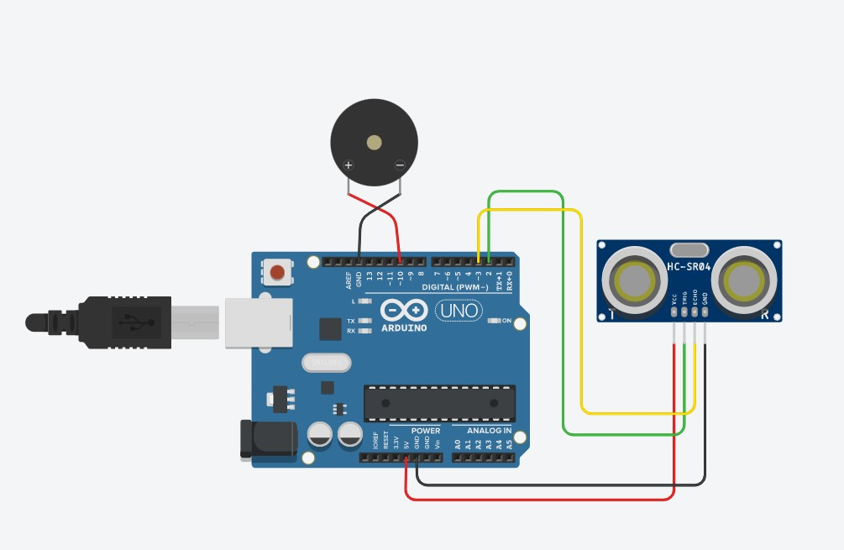

Whenever anyone comes in the path/range of Ultrasonic Sensor,microcontroller detects the distance of object is in the defined range, it sends the High signal to the buzzer and buzzer starts beeping.